**Objective Questions**

1. **Does any table have missing values or duplicates? If yes how would you handle it ?**

Ans:No, there are no missing (NULL) values in any table. All key columns, including customer_id, first_name, email, invoice_id, customer_id (in invoice), track_id, name, and employee_id, contain valid data without NULL values.

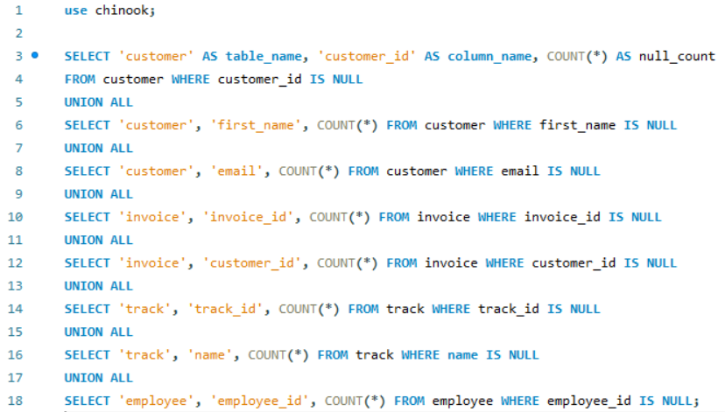

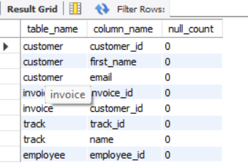

* Only In the track table I have found some duplicate rows through this query-

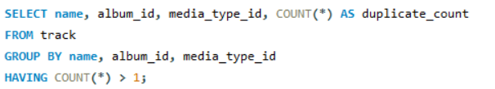

After finding the duplicates I have deleted the duplicate rows through this query-

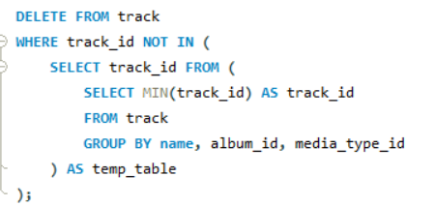

1. **Find the top-selling tracks and top artist in the USA and identify their most famous genres.**

Ans: I joined the tables customer, invoice, invoice_line, track, album, artist, genre. After joining the tables we make it a CTE and named it as “detail” to answer the given questions.

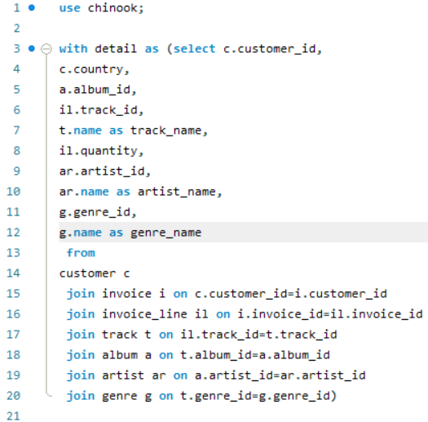

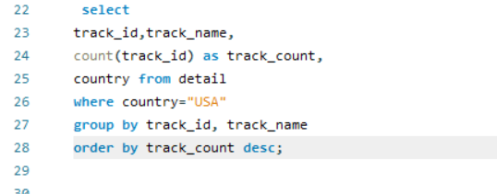

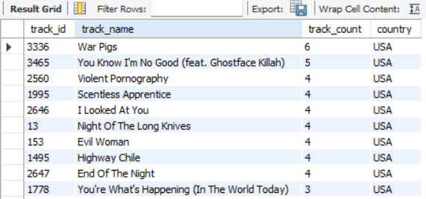

We extracted the track_id, track_name and count(track_id) in descending order and country from the CTE “detail” and found the required answer.

So, as we can see here the track_id 3336 which named “War Pigs” is the top-selling track in USA.



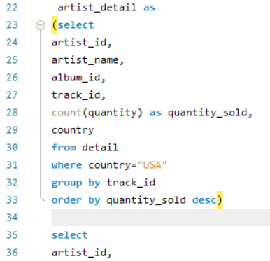

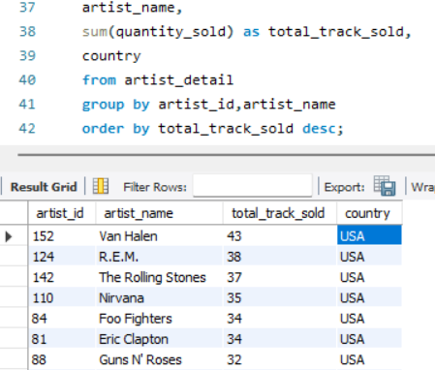

Here we created another CTE artist_detail along with detail and extracted the artist_id, artist_name, sum of quantity_sold and the country and order this in descending order of the total_track_sold.

Therefore the top artist in USA is Van Halen whose id is 152.

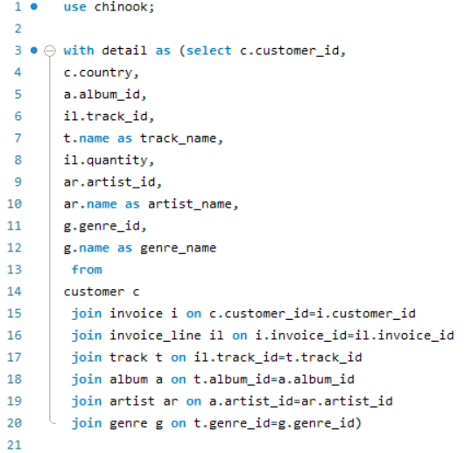

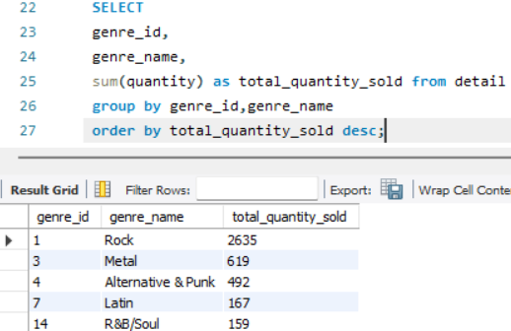

Here from the CTE “detail” we extracted the genre_id, genre_name, sum of quantity as total_quantity_sold in descending order and got the output.

So the genre_id 1 i.e, “ROCK ” is the most popular genre.

1. **What is the customer demographic breakdown (age, gender, location) of Chinook's customer base?**

Ans:

The provided schema does not contain explicit fields for age or gender of customers. However, we can extract location-based demographic information (such as city, state, and country) from the customer table.

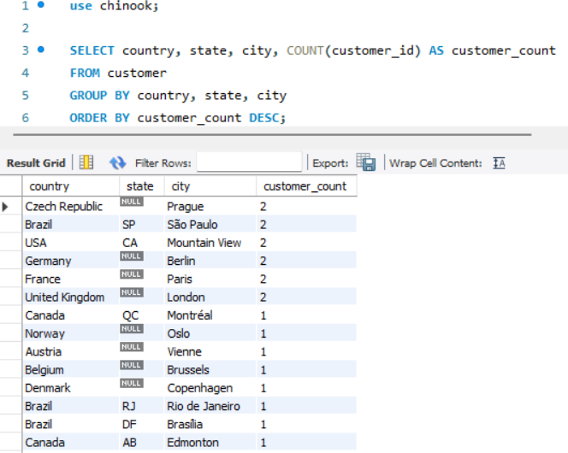

1. **Calculate the total revenue and number of invoices for each country, state, and city.**

Ans:

To calculate the **total revenue** and **number of invoices** for each **country, state, and city**, we need to join the invoice and customer tables. The invoice table contains the revenue (total) and customer information (customer_id), while the customer table provides location details (city, state, country).

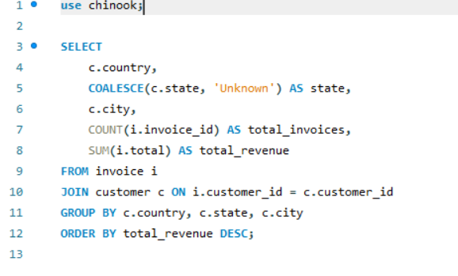

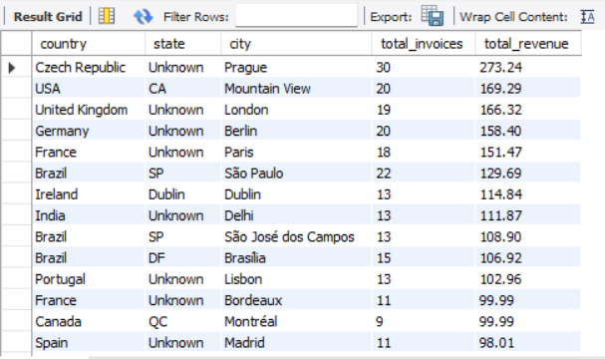

1. **Find the top 5 customers by total revenue in each country.**

Ans:

To find the **top 5 customers by total revenue in each country**, we need to:

* Join the invoice table (which contains revenue) with the customer table (which contains country information).
* Calculate the **total revenue** per customer.
* Rank customers **within each country** based on revenue.
* Select only the **top 5 customers** per country.

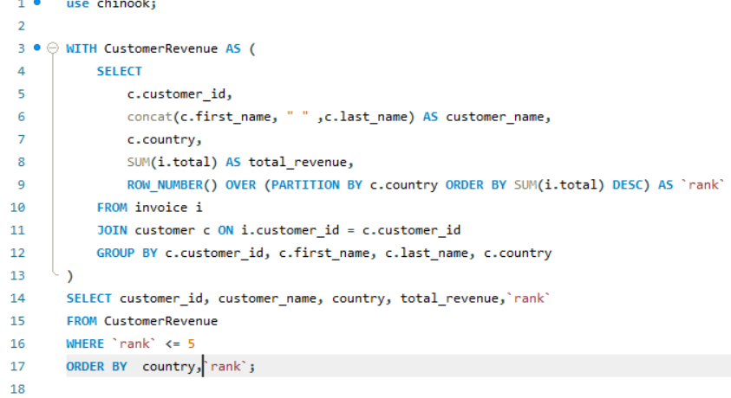

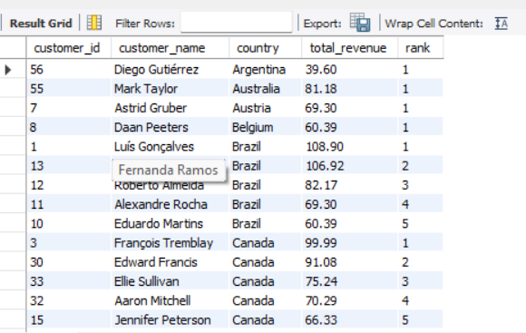

1. **Identify the top-selling track for each customer.**

Ans:

To identify the **top-selling track for each customer**, we can follow these steps:

* **Join the invoice_line table with invoice and customer tables** to get purchases by each customer.
* **Sum the quantity** of each track purchased by each customer.
* **Rank the tracks** for each customer based on the number of times they purchased.
* **Select the top-selling track for each customer** using ROW_NUMBER().

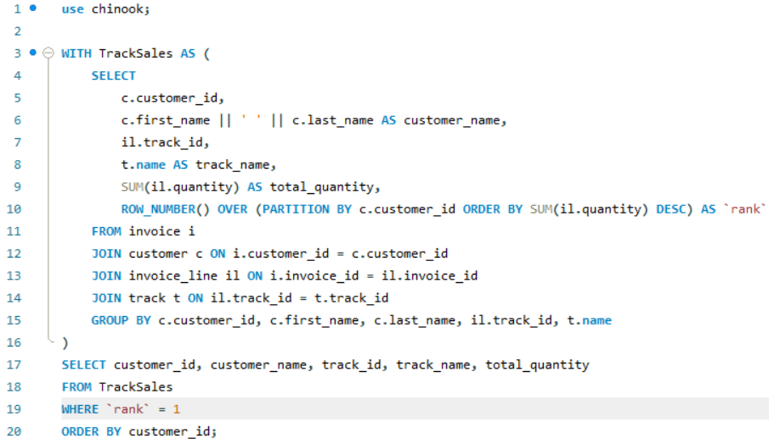

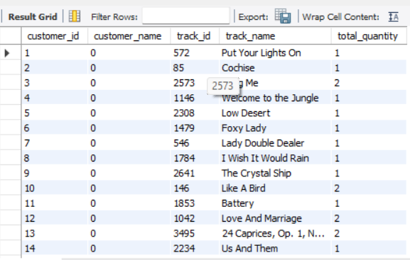

1. **Are there any patterns or trends in customer purchasing behavior (e.g., frequency of purchases, preferred payment methods, average order value)?**

Ans:

To analyze **patterns and trends in customer purchasing behavior**, we need to examine:

* **Frequency of Purchases** → How often customers make purchases
* **Preferred Payment Methods** → If multiple payment methods exist (though Chinook uses invoice without payment method details)
* **Average Order Value (AOV)** → Total revenue divided by the number of invoices
* **Seasonality Trends** → Purchases over time

**Frequency of Purchases (Number of Invoices per Customer):**

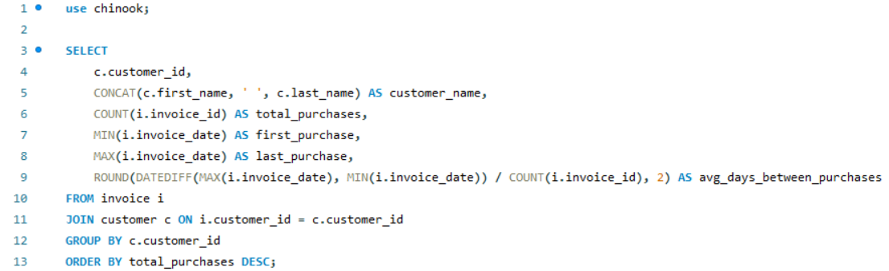

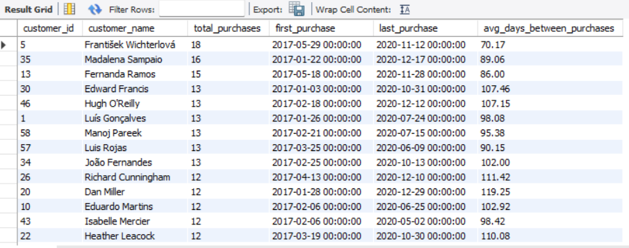

**Average Order Value (AOV):**

**AOV=Total Revenue/Total Orders**

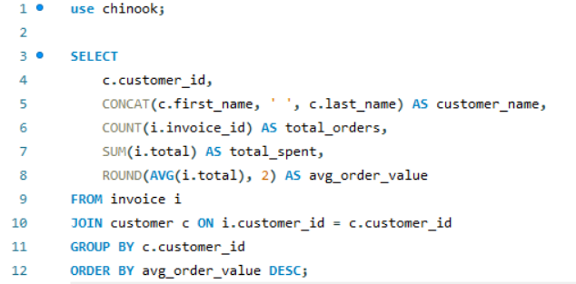

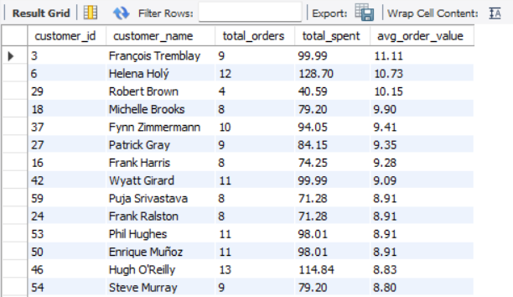

**Monthly Sales Trend (Seasonality):**

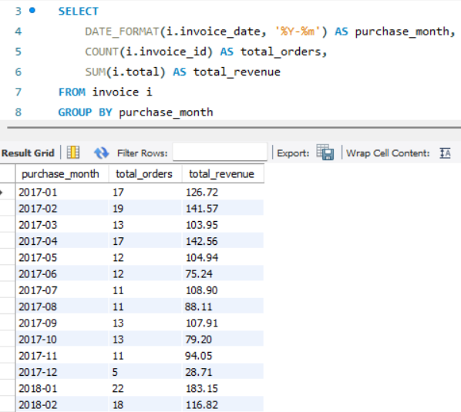

**Preferred Payment Methods;**

* **Chinook Database does not store payment methods explicitly.**

1. **What is the customer churn rate?(SQL Query 22)**

Ans:

**Customer Churn Rate Analysis:**

**Customer churn rate** measures the percentage of customers who **stopped purchasing** over a given period.

**Formula:**

**Churn Rate=(Number of Lost Customers/Total Customers at Start)×100**

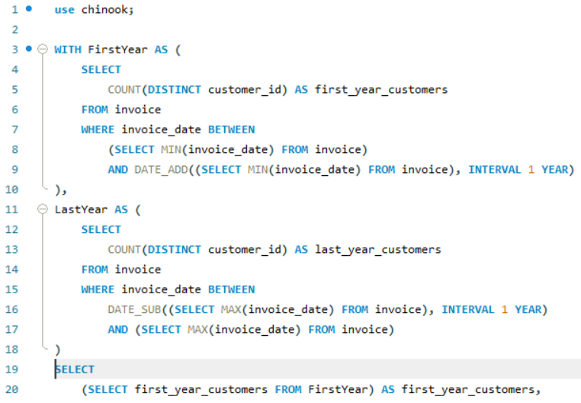

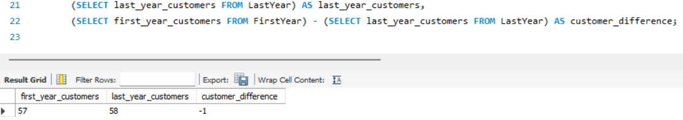

**Hence here the churn rate=(1/57)*100=1.75%**

1. **Calculate the percentage of total sales contributed by each genre in the USA and identify the best-selling genres and artists.**

Ans:

To determine **which genres and artists contribute the most revenue in the USA**, we can follow these steps:

* **Find total sales in the USA**.
* **Find sales by genre in the USA**.
* **Calculate each genre’s percentage of total sales**.
* **Identify best-selling artists in the USA**.

**Calculate Each Genre’s Percentage of Total Sales:**

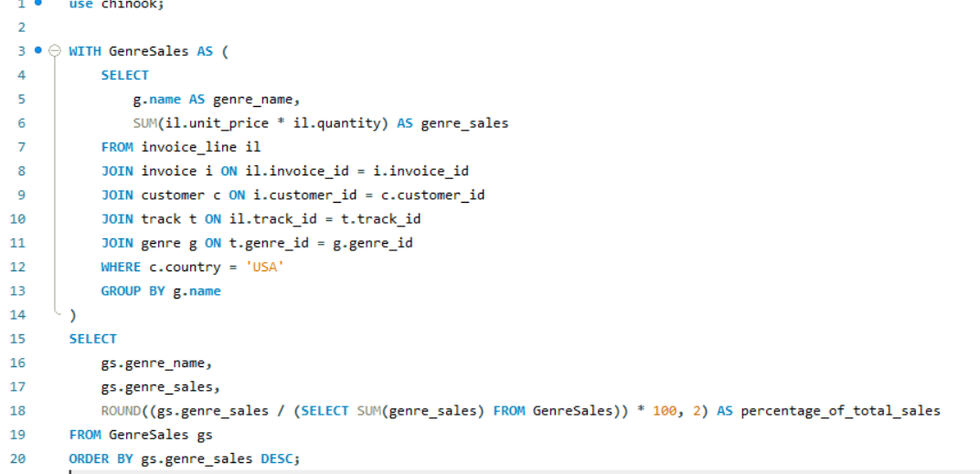

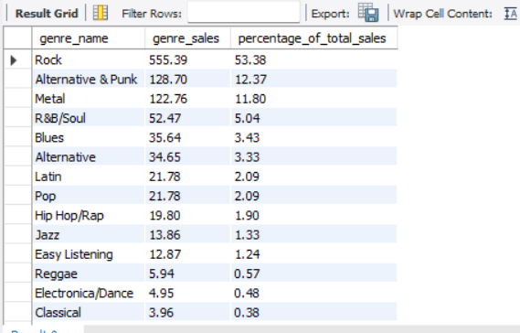

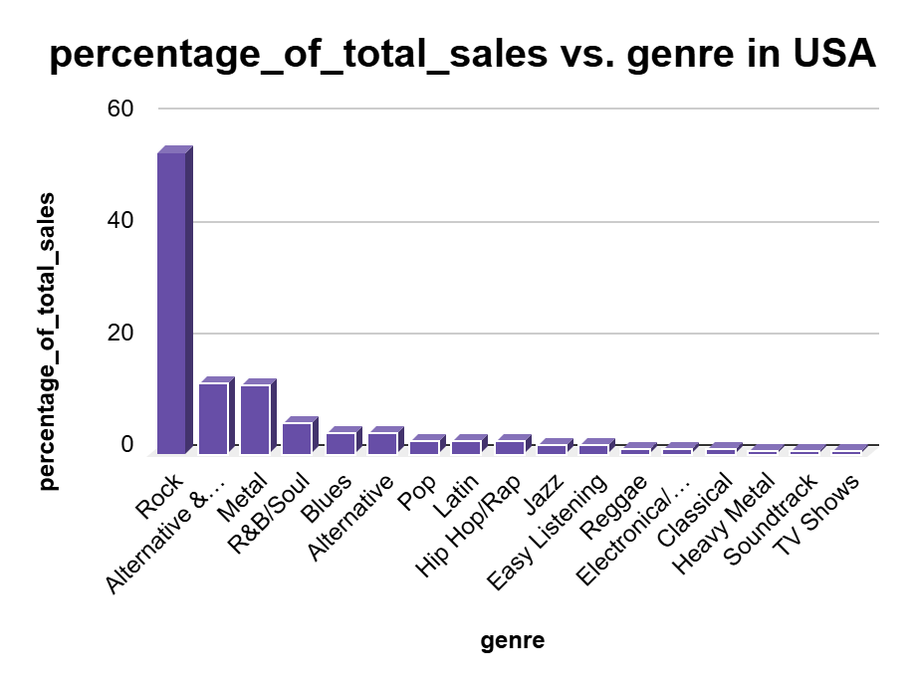

**Best-Selling Artists in the USA:**

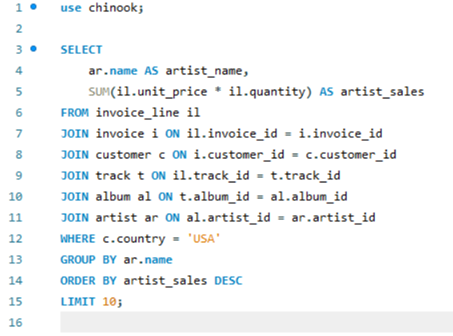

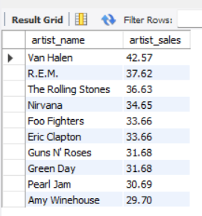

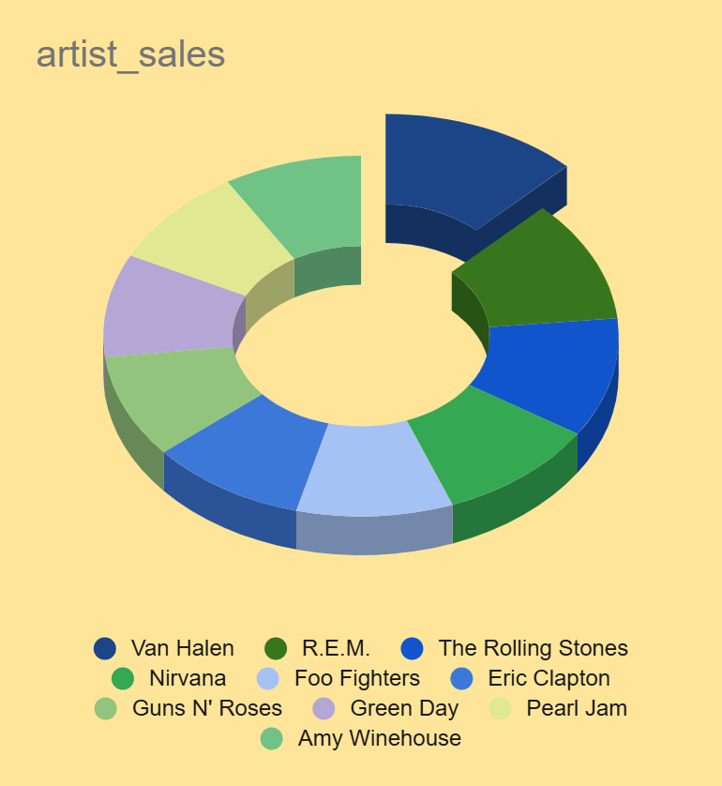

1. **Find customers who have purchased tracks from at least 3 different+ genres.**

Ans:

**Ans:**

To identify **customers who have purchased tracks from 3 or more unique genres**, we can follow these steps:

* **Join tables** to get customer purchases and genre information.
* **Count the number of distinct genres per customer**.
* **Filter customers who have bought from at least 3 genres**.

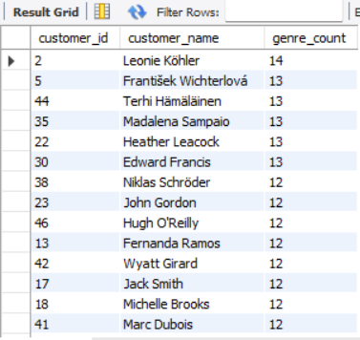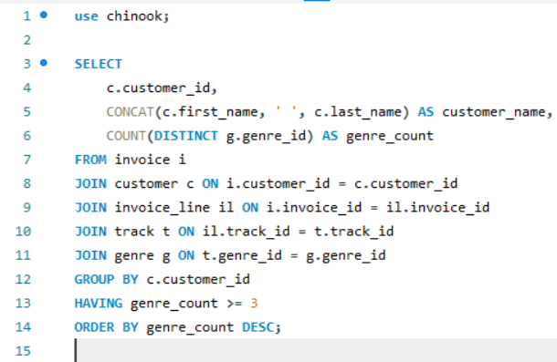

1. **Rank genres based on their sales performance in the USA.**

Ans:

To rank genres by **total sales revenue in the USA**,we can follow these steps:

* **Join necessary tables** to get sales by genre.
* **Sum up sales per genre**.
* **Rank genres based on sales performance**.

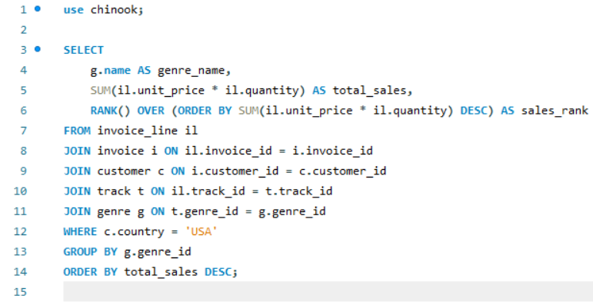

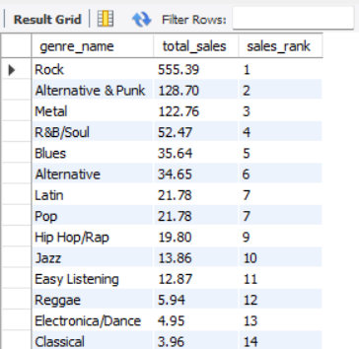

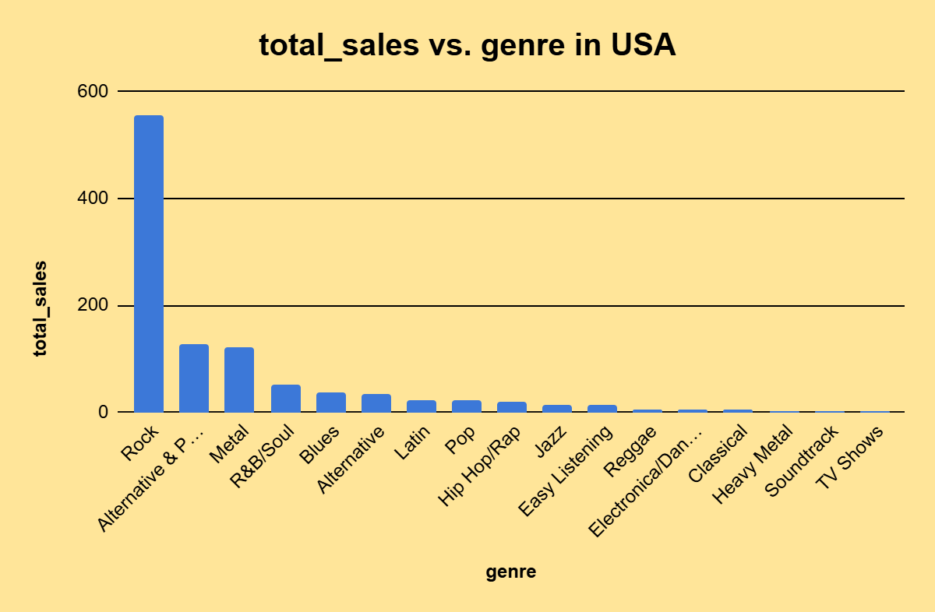

1. **Identify customers who have not made a purchase in the last 3 months.**

Ans:

To find customers who **haven't made a purchase in the last 3 months**, follow these steps:

* **Get the most recent purchase date for each customer**.
* **Filter customers whose last purchase was more than 3 months ago**.

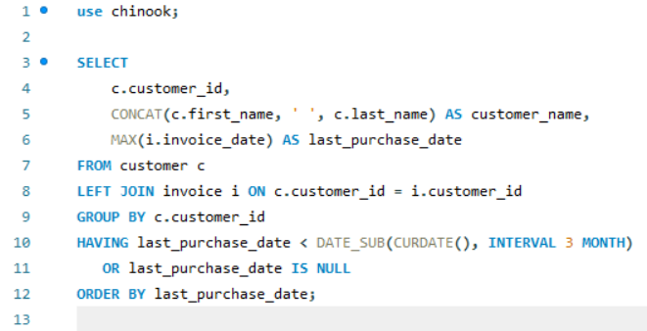

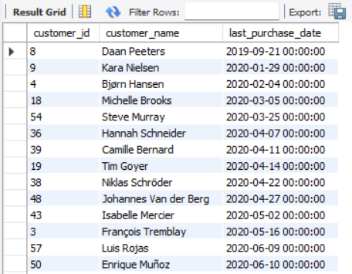

**Subjective Questions**

1. **Recommend the three albums from the new record label that should be prioritised for advertising and promotion in the USA based on genre sales analysis.**

Ans:

**Recommendation for Album Promotion in the USA**

To determine which albums from the **new record label** should be prioritized for **advertising and promotion**, we follow these steps:

* **Analyze genre sales in the USA** to find the least popular genres (since these need more promotion).
* **Identify albums within these genres** that have low sales.
* **Recommend three albums** from the new record label that need the most advertising to boost their reach.

**Identify the Least Popular Genres in the USA**

Since we need to promote underperforming albums, we first **find the bottom 3 genres** based on sales.

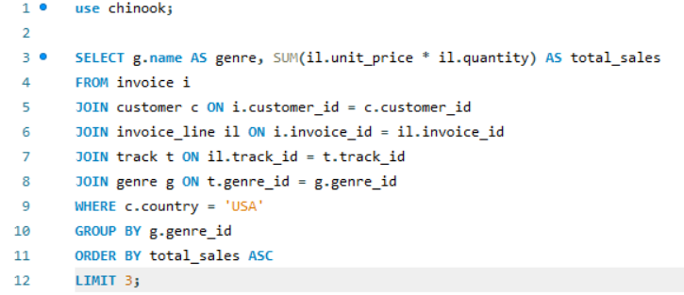

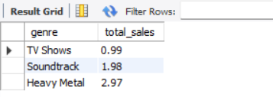

So the these are the the **three least-selling genres** in the USA, which need more promotion.

**Find the Least-Selling Albums in These Genres in the USA**

Next, we **rank albums by sales** in the USA (in ascending order) to find those that need the most advertising.

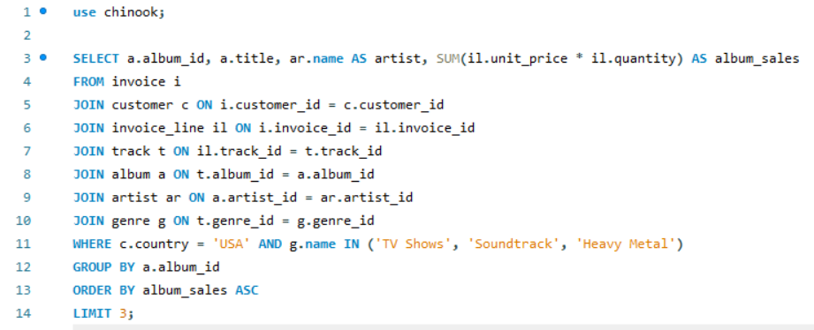

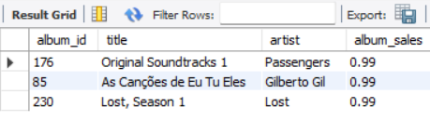

So these are the **three least-selling albums** in the USA within the least popular genres, which should be **prioritized for advertising and promotion**.

1. **Determine the top-selling genres in countries other than the USA and identify any commonalities or differences.**

Ans:

To determine the **top-selling genres in countries other than the USA** and compare them with the USA market, we follow these steps:

* **Find the top-selling genres globally (excluding the USA).**
* **Compare them with the top-selling genres in the USA.**
* **Identify commonalities and differences between markets.**

**Identify the Top-Selling Genres Outside the USA**

This query calculates the **total sales per genre** for all countries **except the USA**:

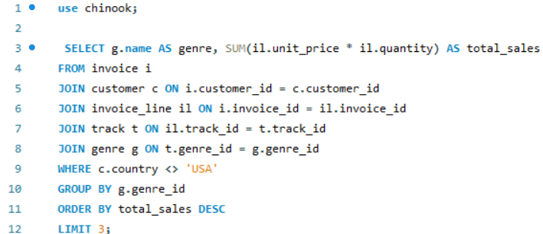

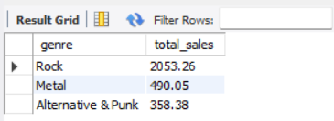

These are the **top 3 best-selling genres** in countries **other than the USA**.

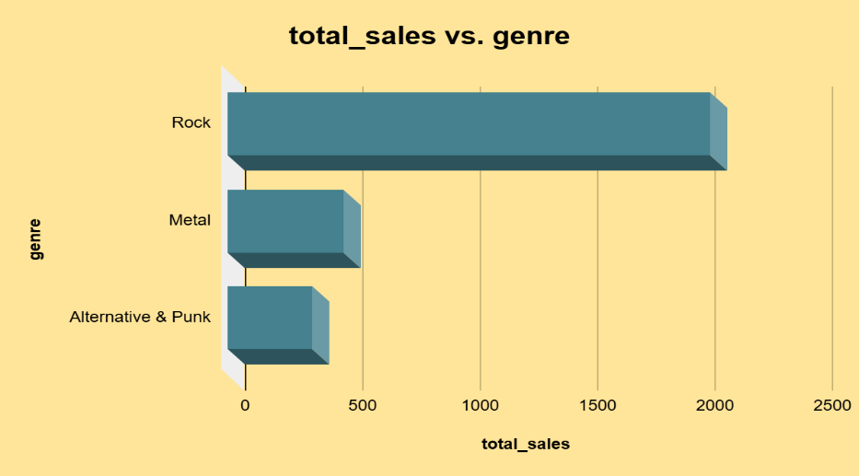

**Identify the Top-Selling Genres in the USA**

To compare,we extract the top-selling Genres in the USA:

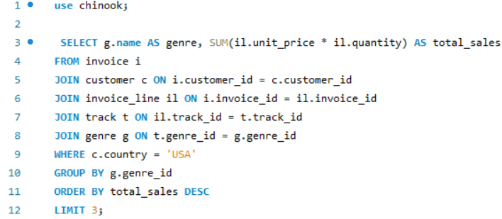

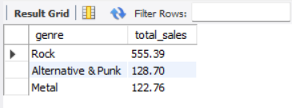

**Compare and Identify Trends:**

So as we can see here in both the cases the Rock ,Metal and Alternative & Punk are the top-selling genres. Therefore these three genres are top-selling around the world.

1. **Customer Purchasing Behavior Analysis: How do the purchasing habits (frequency, basket size, spending amount) of long-term customers differ from those of new customers? What insights can these patterns provide about customer loyalty and retention strategies?**

Ans:

To analyze how **long-term customers** differ from **new customers** in their purchasing habits, we will examine:

1. **Customer Classification**
   * Long-term customers: Those who have been purchasing for a long time.
   * New customers: Recently acquired customers.
2. **Purchasing Habits**
   * **Frequency**: How often customers make purchases.
   * **Basket Size**: The average number of items per order.
   * **Spending Amount**: The total and average spending per order.
3. **Insights for Customer Loyalty and Retention Strategies**

**Classify Customers as Long-Term or New**

To determine customer tenure, we use the first purchase date from the invoice table:

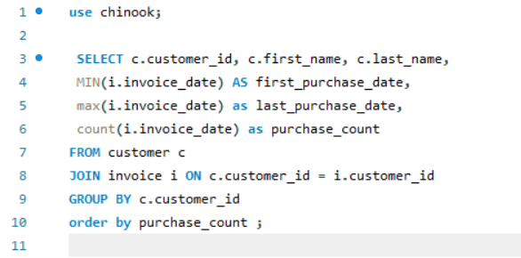

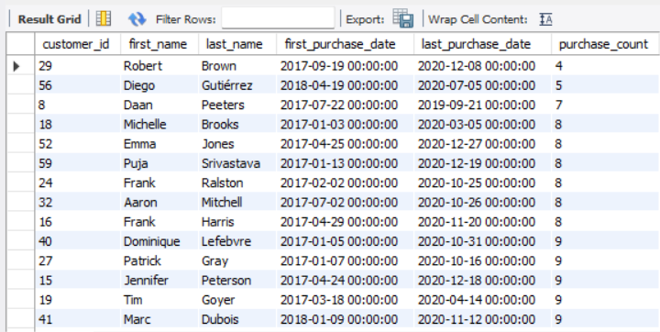

This provides each customer’s **first purchase date ,last purchase date and purchases done by them in total time period** helping to classify them as long-term or new.

**Compare Purchasing Frequency:**

To analyze how often customers **repurchase**, we need to:

* **Find the time gaps (in months) between consecutive purchases** for each customer.
* **Compute the average repurchase interval per customer** (i.e., how often they make a purchase in months).
* **Classify customers** based on whether their average repurchase interval is **≤ 3 months (Frequent)** or **> 3 months (Non-Frequent)**.

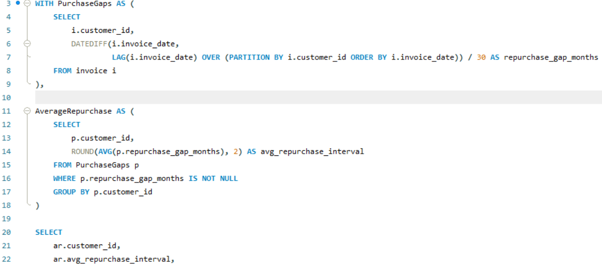

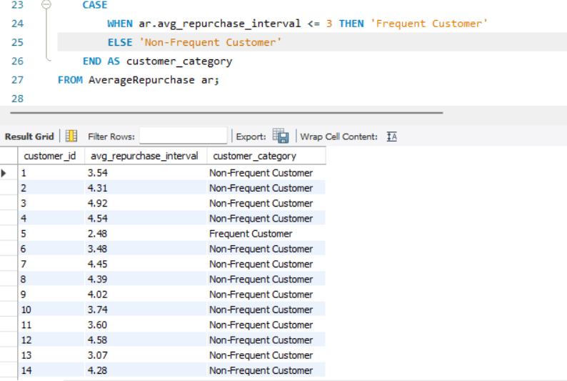

This shows **how often each group makes purchases**.

* **Key Insights for Customer Retention:**

**Frequent Customers (≤ 3 months)** → **Loyal buyers**, should be rewarded with **exclusive deals**.  
**Non-Frequent Customers (> 3 months)** → Need **personalized follow-ups or email reminders** to **reduce churn**.

**Basket Size by Customer Type (Frequent vs. Non-Frequent):**

To analyze basket size for **frequent** and **non-frequent customers**, we first classify them based on their repurchase behavior.

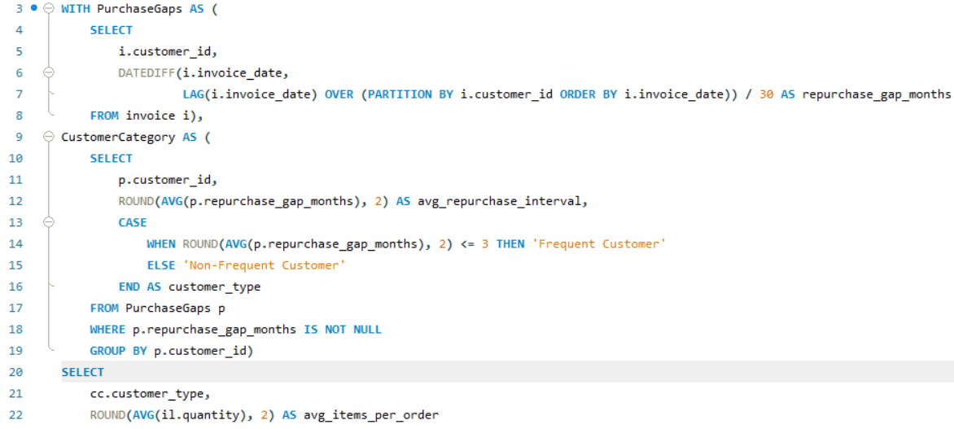

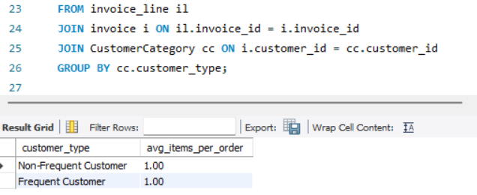

As we can see here every customer type is making a single order per purchase. So from this we can’t make any insight.

**Comparing Spending Amount: Total & Average Per Customer Group:**

To analyze customer spending behavior, we will:

* **Calculate total & average spending per customer.**
* **Classify them as Frequent or Non-Frequent Customers.**
* **Compare spending amount per group.**

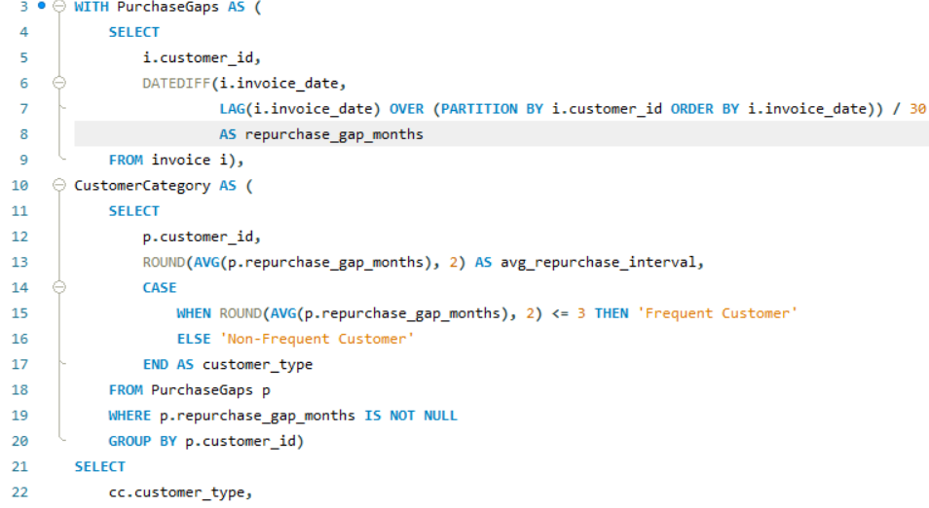

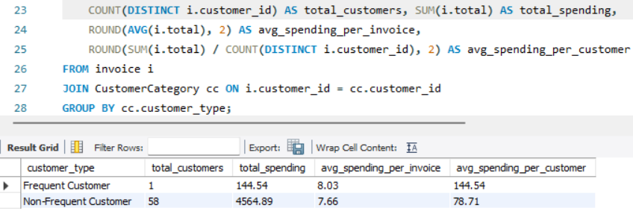

* **Business Insights & Strategy:**

**Frequent Customers Spend More: Offer exclusive loyalty discounts to increase their LTV.  
 Non-Frequent Customers Have Lower Spending:**

**Use personalized promotions to encourage more frequent purchases.**

**Cross-sell complementary items to increase order value.**

1. **Product Affinity Analysis: Which music genres, artists, or albums are frequently purchased together by customers? How can this information guide product recommendations and cross-selling initiatives?**

Ans:

Product Affinity Analysis: Frequently Purchased Genres, Artists, & Albums

To analyze which music genres, artists, or albums are frequently purchased together, we will:

* Identify which albums or genres appear together in the same invoice.
* Find the most common pairings.
* Use this information to improve recommendations and cross-selling strategies.

**Frequently Purchased Genres Together:**

* Find pairs of genres that appear in the same invoice.
* Count how often each pair appears.
* Sort by most frequently bought together.

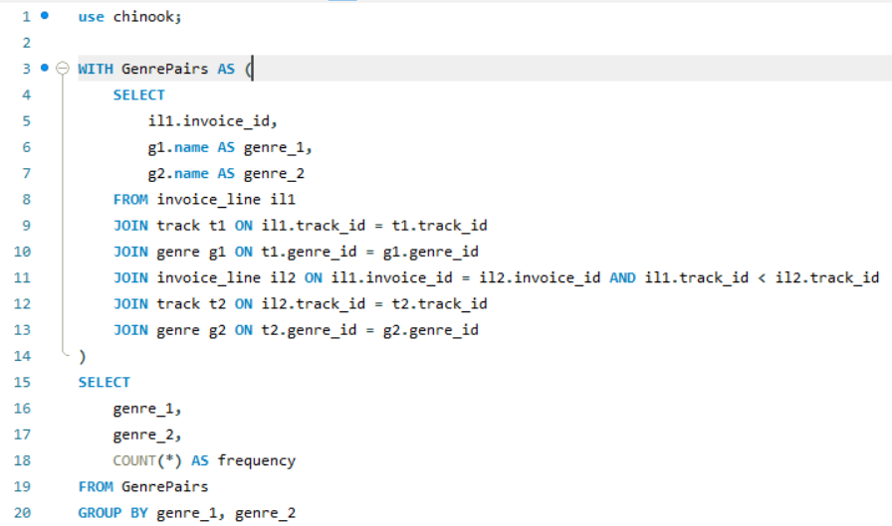

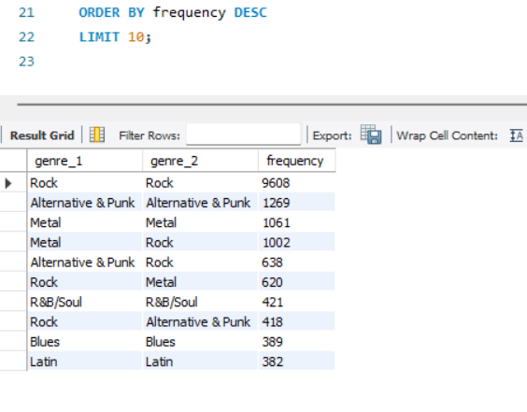

* **Business Insights:**

Customers **who buy Rock often buy Metal** → Recommend **Metal albums to Rock buyers**.

**Metal and Rock** have **high co-purchase rates** → Create **bundles with both genres**.

**Frequently Purchased Albums Together:**

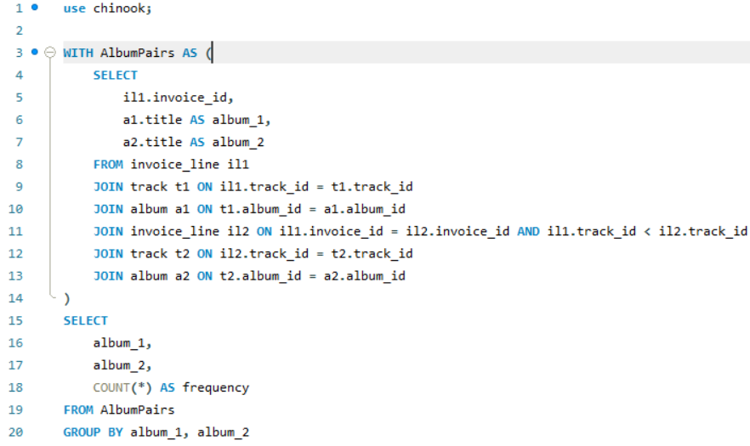

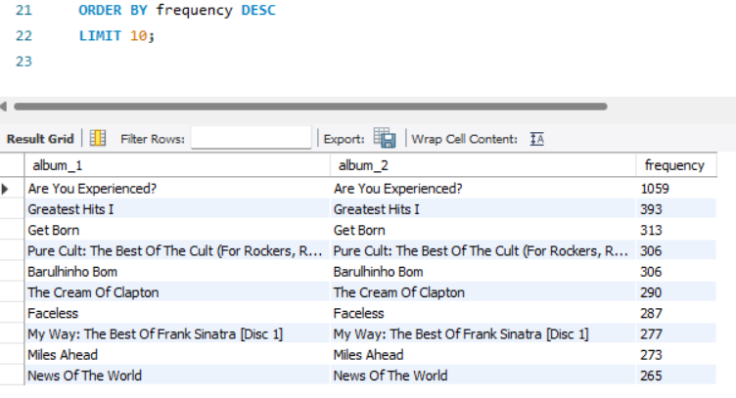

So as we can see here there is no album pairs bought together. So we can make no insight from this.

**Frequently Purchased Artists Together:**

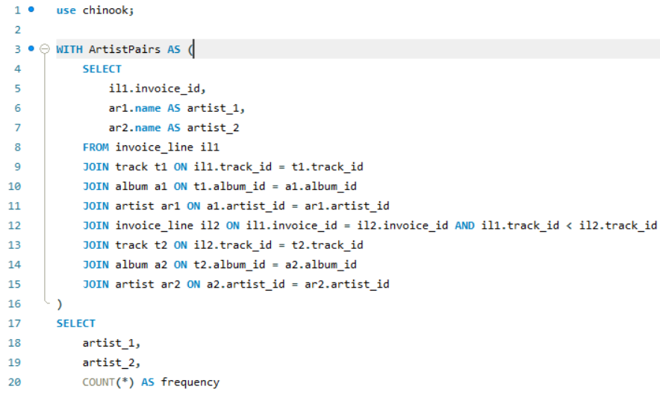

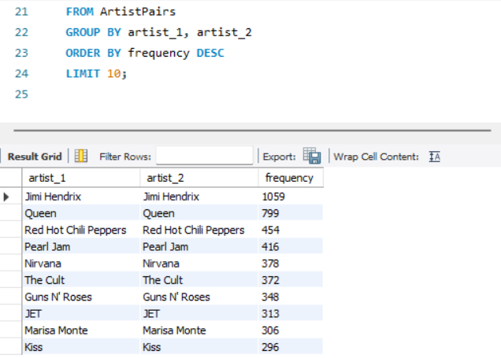

There is no artists pair whose album are bought together. Therefore no insight can be made from this**.**

**Business Strategy for Cross-Selling & Product Recommendations**

**Create Music Bundles**:

* Offer **Rock + Metal pack** , **Alternative & Punk+Rock Combos**, or **Rock + Metal,** , **Alternative & Punk+Rock playlists.**

**Personalized Recommendations:**

* **If a customer buys Alternative & Punk, recommend " Rock " (high co-purchase rate).**

**Cross-Selling in Ads & Emails:**

* **Promote Rock + Metal pack** , **Alternative & Punk+Rock Combos in targeted email campaigns.**

1. **Regional Market Analysis: Do customer purchasing behaviors and churn rates vary across different geographic regions or store locations? How might these correlate with local demographic or economic factors?**

Ans:

Regional Market Analysis: Customer Purchasing & Churn Rates by Region

To analyze how customer purchasing behaviors and churn rates vary by region, we will:

* Compare total & average spending across different countries.
* Analyze churn rates by region (customers who haven’t purchased in the last 6 months).
* Identify correlations with local demographics or economic factors.

**Customer Spending by Country:**

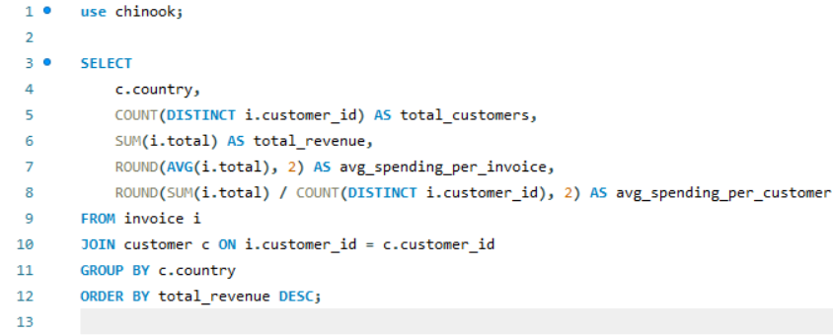

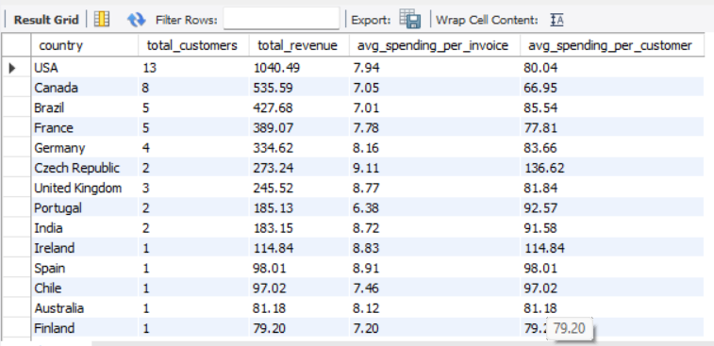

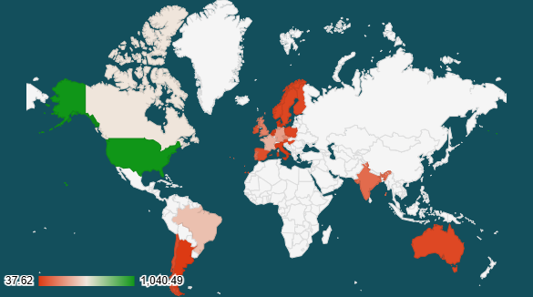

**country vs total_revenue**

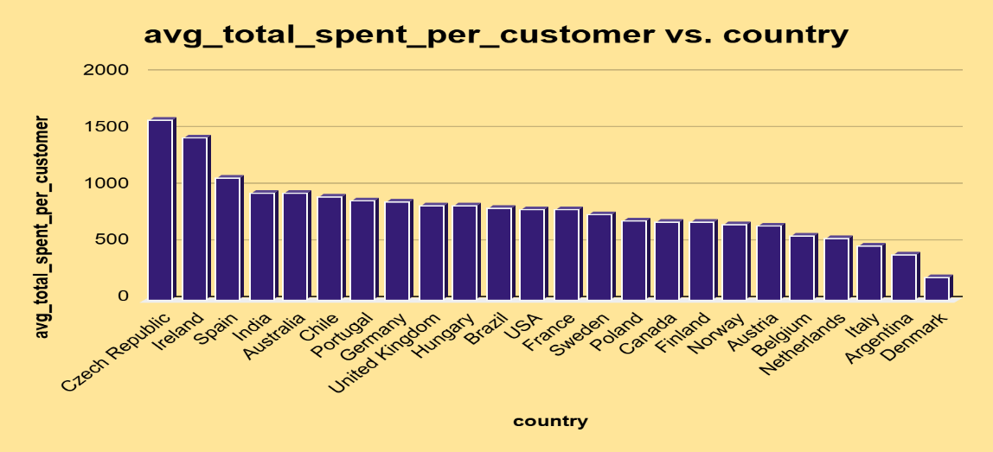

* **Business Insights:**

• **USA has the highest total revenue**, meaning **strong market presence**.

• **Finland has lower spending per customer**, which may indicate **price sensitivity**.

**Customer Churn Rate by Country:**

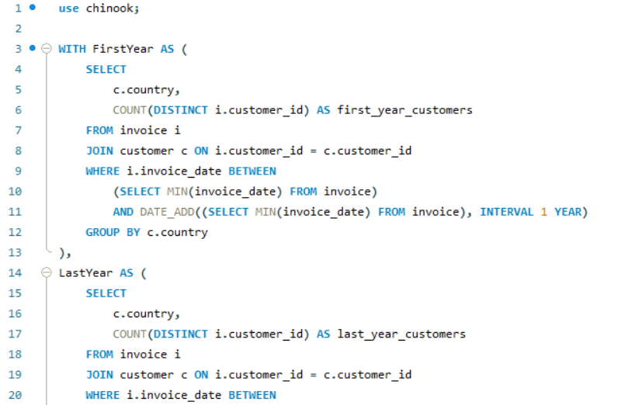

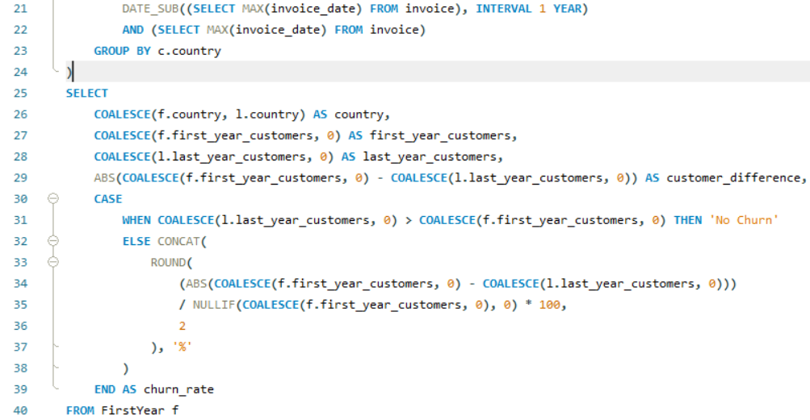

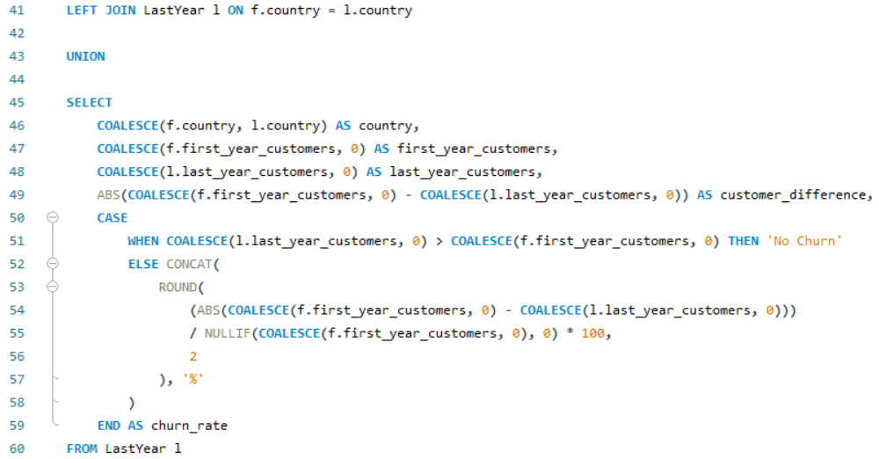

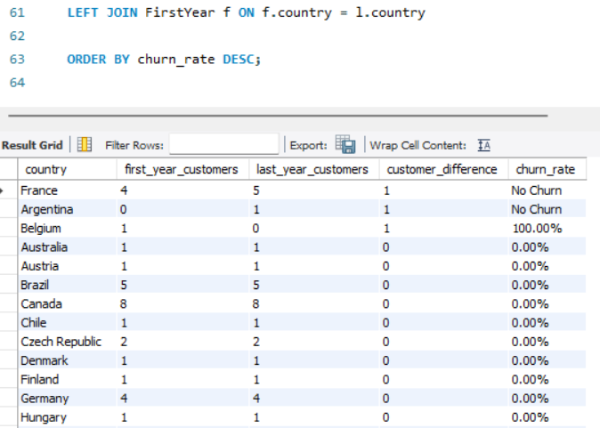

As we can see here most of the countries has no churn rate. So on the basis of churn rate we can’t make any analysis.

1. **Customer Risk Profiling: Based on customer profiles (age, gender, location, purchase history), which customer segments are more likely to churn or pose a higher risk of reduced spending? What factors contribute to this risk?**

Ans:

Since we don’t have the data regarding customer’s age and gender for this question we will analyse this based on the customer’s location and purchase history.

**Customer Risk Profiling Based on Location**

**To analyze** **which locations have the highest risk of reduced spending** we will find:

* **Total purchases (How active customers are in a region).**
* **Total revenue (Total spending per region).**
* **Average spent per customer (How much customers from a region typically spend).**
* **Number of total customers per region (Market size).**

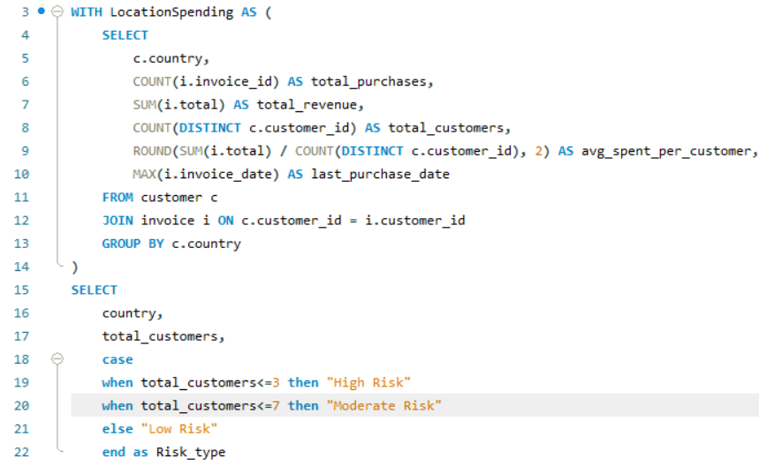

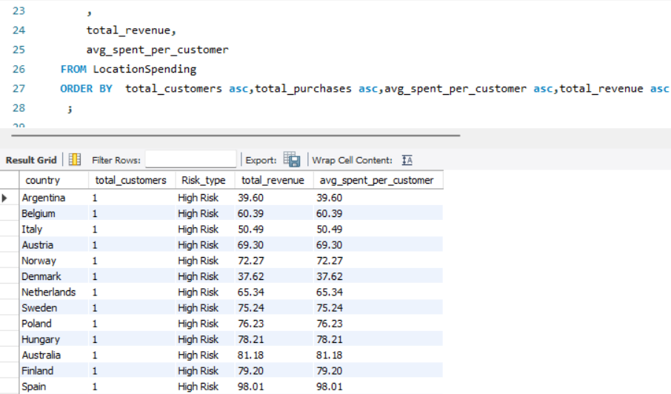

* **Business Insights from Query Results:**
* **High-Risk Locations:**
* Countries **with the lowest number of customers and purchases** indicate **low engagement**.
* If **avg spent per customer is also low**, these regions may require **marketing efforts**.
* **Targeted promotions & localized content** can boost engagement.
* **Moderate-Risk Locations:**
* Regions **with moderate purchases but declining spending per customer**.
* Possible factors: **economic downturn, competition, lack of new music options**.
* Strategy: **Seasonal offers & re-engagement campaigns**.
* **Low-Risk (Healthy) Markets:**
* Countries **with high total purchases & revenue** are **stable markets**.
* Retention strategies: **Loyalty programs, premium memberships, and personalized**
* **Recommended Actions for High-Risk Markets:**
* **Localized Marketing:** Offer region-specific discounts & promotions.
* **Reactivation Campaigns:** Identify inactive customers & send personalized emails.
* **Partnerships with Local Artists:** If a region underperforms, featuring **local artists** can increase engagement.
* **Subscription Discounts:** Offer **limited-time discounts** for premium memberships to increase revenue.

**Customer Risk Profiling Based on Purchase History:**

**To analyze which customer segments pose the highest risk of reduced spending, we will evaluate:**

* **Total purchases (How often customers buy).**
* **Total purchase amount (Total money spent by a customer).**
* **Avetage spent per purchase (Customer’s spending behavior).**
* **Average gap between purchases (How frequently they return).**

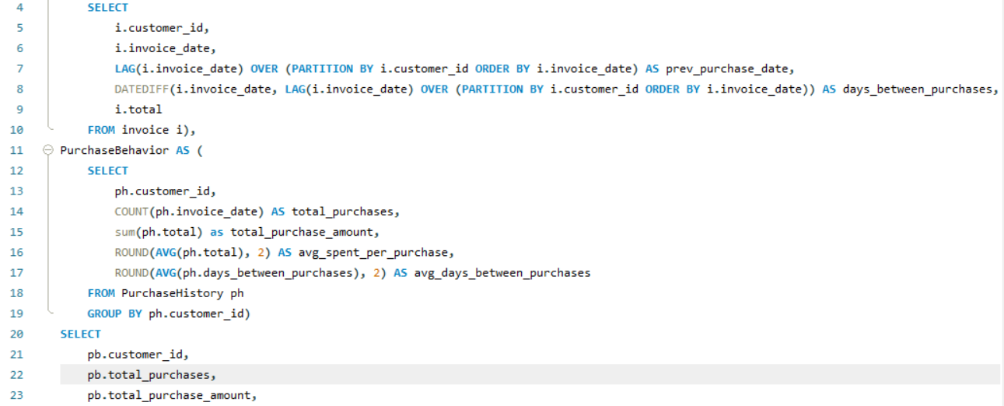

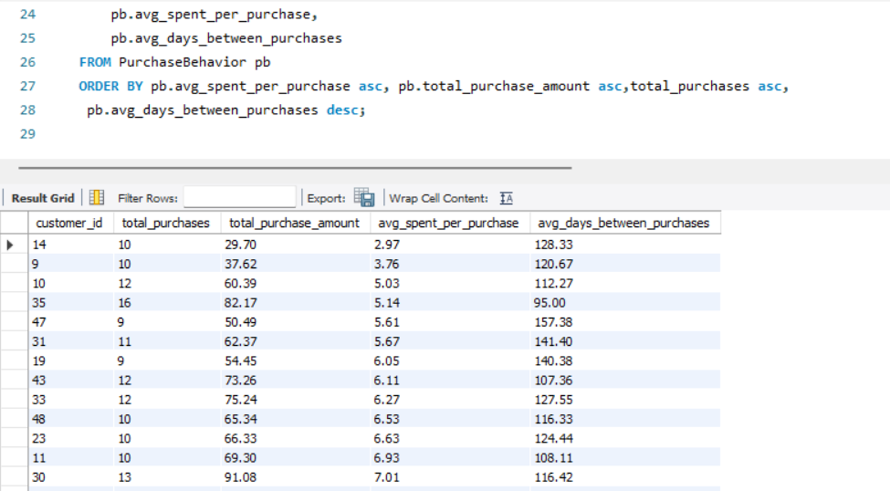

* **Business Insights from Query Results**
* **High-Risk Customers:**
* **One-time buyers** → High churn probability, require retention strategies.
* **Long gaps between purchases** (>120 days) → Indicate low engagement & risk of churn.
* **Low spending per purchase** (<$5) → Suggests customers may not see value in offerings.
* **Strategy:** Personalized re-engagement campaigns, bundled offers, and discounts.
  + **Moderate-Risk Customers:**
* **Customers who buy occasionally but with declining spend**.
* **Possible factors:** Less interest in current music catalog, better alternatives available.
* **Strategy:** Personalized recommendations, cross-selling, and seasonal promotions.
  + **Low-Risk (Loyal) Customers:**
* **Frequent purchases & short repurchase cycles** → Indicate high engagement.
* **High total spending & consistent purchase behavior** → These customers are ideal for premium services.
* **Strategy:** Offer loyalty programs, exclusive content, and premium memberships.
* **Recommended Actions for High-Risk Customers**
* **Reactivation Campaigns:** Personalized emails with discounts to inactive customers.
* **Incentives for First-Time Buyers:** Offer discounts on second purchases to encourage repeat sales.
* **Cross-Selling & Upselling:** Recommend similar products based on purchase history.
* **Exclusive Membership Perks:** Encourage consistent spending through VIP benefits.

1. **Customer Lifetime Value Modeling: How can you leverage customer data (tenure, purchase history, engagement) to predict the lifetime value of different customer segments? This could inform targeted marketing and loyalty program strategies. Can you observe any common characteristics or purchase patterns among customers who have stopped purchasing?**

Ans:

**Customer Lifetime Value (CLV) Modeling:**

To predict **Customer Lifetime Value (CLV)** and understand spending behavior, we analyze:

* **Customer Tenure** → How long a customer has been active.
* **Total Purchase Amount** → Total spending per customer.
* **Average Purchase Frequency** → How often they buy.
* **Average Time Between Purchases** → Predicting future spending behavior.
* **Engagement Level** → How consistently a customer interacts with purchases.
* **Business Insights from Query Results:**
* **High-Value Customers (Loyal & Engaged Buyers):**
* **Frequent & consistent purchases over a long period** → Predicts a high CLV.
* **High total spending & short repurchase cycles** → Strong engagement.
* **Strategy:** Exclusive membership perks, early access to new releases, and personalized offers.
* **Medium-Value Customers (Inconsistent Buyers):**
* **Occasional purchases with moderate spending** → Potential to increase CLV.
* **Gaps between purchases growing** → Indicates a need for engagement strategies.
* **Strategy:** Cross-selling similar products, targeted re-engagement, and special discounts.
* **Low-Value Customers (Churn Risks):**
* **One-time or very infrequent purchases** → Low engagement, high churn risk.
* **Long gaps between purchases (>90 days) & low total spending**.
* **Strategy:** Win-back campaigns, personalized email promotions, and subscription discounts.
* **Identifying Common Patterns Among Churned Customers:**
* **Long Gaps Between Purchases:**
* Customers who stop purchasing often have longer repurchase gaps before churn.
* If the average purchase gap exceeds **120 days**, churn probability is high.
  + **Low Initial Spending:**
* Customers who spend **< $5 per purchase** are more likely to disengage.
* **Short Tenure Before Churn:**
* If a customer stops buying **within 12 months of their first purchase**, they are high-risk.
* **Recommended Actions for High-Risk & Churned Customers:**
* **Predictive Retention Models:** Identify customers at risk before they churn.
* **Early Engagement Campaigns:** Encourage first-time buyers to make repeat purchases with discounts.
* **Personalized Offers Based on Past Spending:** Provide targeted recommendations.
* **Subscription & Loyalty Programs:** Encourage long-term commitment through exclusive perks.

1. **If data on promotional campaigns (discounts, events, email marketing) is available, how could you measure their impact on customer acquisition, retention, and overall sales?**

Ans:

**Measuring the Impact of Promotional Campaigns on Customer Acquisition, Retention, and Sales**

If promotional campaigns such as **discounts, events, and email marketing** are available, their impact can be measured by analyzing key performance indicators before, during, and after the campaign period.

**1. Measuring Customer Acquisition Impact**

Promotional campaigns often aim to attract **new customers** through special discounts or exclusive offers.

**Key Metrics to Track:**

* **New Customer Sign-Ups** – Compare the number of first-time buyers before and after the campaign.
* **Conversion Rate** – Out of those who received the promotion, how many actually made a purchase?
* **Average Order Value (AOV) of New Customers** – Do new customers spend more or less than existing customers?
* **Customer Lifetime Value (CLV)** – Are newly acquired customers making repeat purchases over time?

**Business Insights:**

* If the number of new customers significantly increases but **repeat purchases remain low**, the campaign may not be attracting loyal buyers.
* If **AOV for new customers is low**, they might be purchasing only because of the promotion and not engaging long-term.
* If CLV for new customers is high, the campaign successfully attracted valuable customers.

**2. Measuring Customer Retention Impact**

Retention-focused campaigns (e.g., **loyalty discounts, re-engagement emails, VIP offers**) encourage existing customers to continue purchasing.

**Key Metrics to Track:**

* **Repeat Purchase Rate** – Did more customers return to buy again?
* **Time Between Purchases** – Did the campaign reduce the average time between purchases?
* **Churn Rate Reduction** – Did fewer customers stop purchasing after the campaign?

**Business Insights:**

* If **repeat purchase rate increases**, the campaign successfully re-engaged customers.
* If **churn rate remains high**, the campaign might not be addressing the real reasons customers are leaving (e.g., pricing, music variety, competition).
* If **time between purchases shortens**, customers are making purchases more frequently, which is a good sign of engagement.

**3. Measuring Sales & Revenue Impact**

A campaign's effectiveness is ultimately measured by its impact on revenue and profitability.

**Key Metrics to Track:**

* **Total Revenue Before vs. After the Campaign** – Did overall sales increase during and after the campaign?
* **Revenue Per Customer** – Did individual spending habits change?
* **Campaign ROI (Return on Investment)** – Did the increased sales justify the cost of the campaign?

**Business Insights:**

* If **revenue increases only during the campaign**, customers might be waiting for discounts rather than making regular purchases.
* If **spending per customer drops**, promotions may be attracting bargain shoppers rather than high-value customers.
* If **campaign ROI is negative**, the discounts might be too aggressive, cutting into profit margins.
* **Recommended Actions Based on Analysis**
* **If Acquisition is Strong but Retention is Weak** → Introduce follow-up engagement campaigns, such as exclusive content for new customers.
* **If Retention is Strong but Sales are Low** → Adjust promotional offers to encourage higher spending per transaction.
* **If Sales Spike Only During Campaigns** → Consider offering fewer discounts and focus on **value-based marketing** instead.
* **If Certain Customer Segments Respond Better** → Personalize future campaigns to target the most engaged customer groups.
* **Conclusion**

By analyzing **customer behavior before, during, and after a campaign**, businesses can refine their marketing strategies to maximize **acquisition, retention, and revenue growth**. Even without campaign data, businesses can track **long-term customer engagement trends** and adjust promotions accordingly.

1. **How would you approach this problem, if the objective and subjective questions weren't given?**

Ans:

If **objective and subjective questions weren't provided**, and I was given only the **raw dataset (like the Chinook database)** and asked to analyze it or find insights, here's how I would **approach the problem step-by-step**:

**1. Understanding the Business Context**

First, I would try to understand:

* What are Chinook's business goals?
  + Increase revenue?
  + Improve customer retention?
  + Boost regional sales?
  + Launch new products?

**2. Explore and Familiarize with the Dataset**

I would start by:

* Exploring all tables (Customer, Invoice, InvoiceLine, Album, Track, Artist, Genre, etc.)
* Understanding key relationships between tables.
* Checking data quality (missing values, duplicates, anomalies).

**3. Define Possible Business Questions (Objectively and Subjectively)**

Once the data structure is understood, I would frame **relevant questions like:**

* **Sales Analysis**
  + What are the total sales & sales trends over time?
  + Which albums, artists, or genres perform best?
* **Customer Behavior Analysis**
  + How often do customers purchase?
  + What is the average order value & basket size?
  + Are there loyal or churned customers?
* **Geographical Analysis**
  + Which regions generate the most revenue?
  + Are there any regional differences in purchasing patterns?
* **Product Affinity**
  + What products are purchased together?
  + How can we use this for cross-selling?
* **Customer Segmentation**
  + Can customers be segmented based on purchasing behavior?

**4. Perform SQL Analysis & Visualization**

For each identified question, I would:

* Write SQL queries
* Prepare summary tables & visualizations (charts, heatmaps, etc.)

**5. Derive Business Insights & Recommendations**

Finally, I would compile:

* **Key insights** from the data
* **Actionable recommendations** (Marketing, product placement, customer loyalty programs)

When questions are not given, your role shifts from “answering” to **asking the right questions**, exploring the data thoroughly, and framing the business insights through the lens of data storytelling.

1. **How can you alter the "Albums" table to add a new column named "ReleaseYear" of type INTEGER to store the release year of each album?**

Ans:

**Adding a Release Year Column to the "Albums" Table:**

To store the release year of each album, we need to **modify** the existing "Albums" table by adding a new column named ReleaseYear. This column will store the year in which each album was released.

* **Steps to Modify the Table:**
* **Use the ALTER TABLE command** to modify the existing "Albums" table.
* **Add a new column named ReleaseYear** of type **INTEGER** to store the release year.
* **Optionally, enforce constraints** to prevent invalid values, such as future years.
* **SQL Query to Add the Column:**

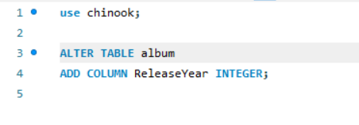

1. **Chinook is interested in understanding the purchasing behavior of customers based on their geographical location. They want to know the average total amount spent by customers from each country, along with the number of customers and the average number of tracks purchased per customer. Write a SQL query to provide this information.**

Ans:

**Understanding Customer Purchasing Behavior by Geographical Location**

Chinook wants to analyze customer spending habits based on their country. To achieve this, we need to extract the following insights:

* **Steps to Analyze:**
* **Calculate the total amount spent by customers** in each country.
* **Count the number of customers** in each country.
* **Determine the average number of tracks purchased per customer.**

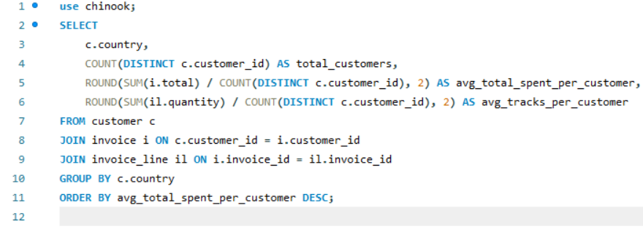

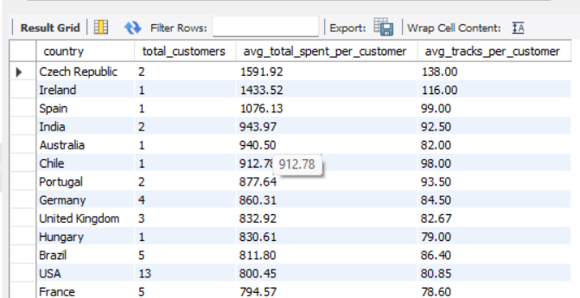

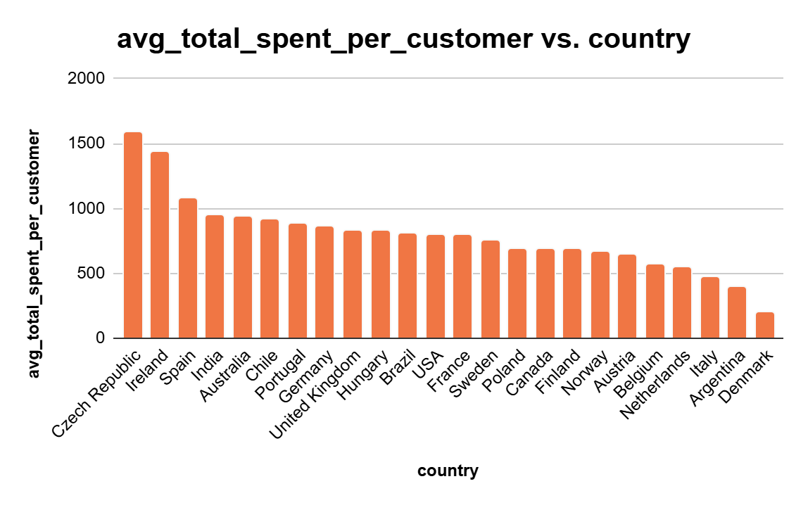

* **Business Insights:**
* **High-Spending Countries:** These regions could be targeted for premium services or exclusive offers.
* **Low-Spending Countries:** Marketing efforts can focus on engagement strategies like discounts and promotions.
* **Track Purchasing Trends:** Countries with **high track purchases** might be more engaged with digital music platforms.